Creation of Saving Account action

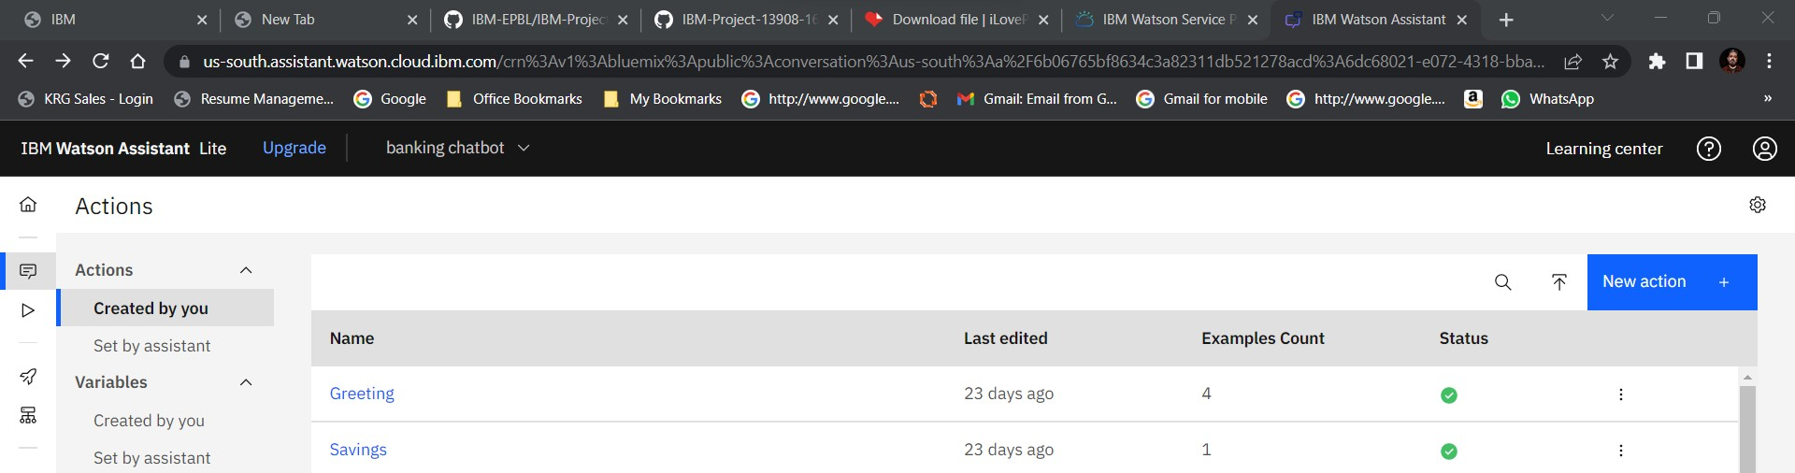

Output screenshot

